**5.1 - SQL SERVER ARCHITECTURE**

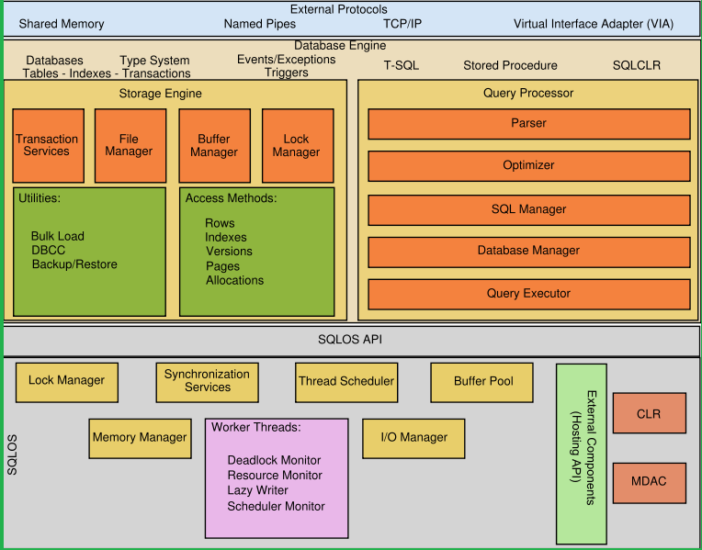

|  |  |
| --- | --- |
| **NETWORK PROTOCOLS** | |
| **SHARED MEMORY** | USED FOR CLIENT - SERVER COMMUNICATION WITH THE **SAME OS** |
| **NAMED PIPES** | USED FOR CLIENT - SERVER COMMUNICATION OVER **LAN** |
| **TCP/IP** | TRANSMISSION CONTROL PROTOCOL or INTERNET PROTOCOL  USED FOR CLIENT - SERVER COMMUNICATION OVER **INTERNET** |
| **VIA** | VIRTUAL INTERFACE FOR CLIENT - SERVER COMMUNICATION. LESS SECURE. |

|  |  |
| --- | --- |
| **DATABASE ENGINE - QUERY PROCESSING ENGINE** | |
| **PARSER** | Used to verify Database Statements and Convert from SQL to Machine Code |
| **QUERY OPTIMIZER** | Used to find the best way to execute the Queries |
| **SQL MANAGER** | Used to reserve the resources required for Query Execution [Memory, CPU] |
| **DATABASE MANAGER** | Used to identify the Tables in the Database File [MDF file] |
| **QUERY EXECUTOR** | Used to perform the actual Query Execution. |
| **DATABASE ENGINE - STORAGE ENGINE** | |
| **TRANSACTION SERVICES** | To control the SQL operations (auto/manual save) |
| **FILE MANAGER** | To identify database files (data files, log files) |
| **BUFFER MANAGER** | To allocate the Memory required for Query Execution |
| **LOCK MANAGER** | To LOCK OR RESERVE DATABASES, TABLES & COLUMNS |

**STORAGE ENTITIES** : ROWS, PAGES, EXTENTS ++ INDEXES

**STORAGE MANAGEMENT ENTITIES** : BULK OPERATIONS CONTROL, **DBCC, BACKUPS**

**DBCC** MEANS : DATABASE CONSISTENCY CHECK COMMAND

|  |  |
| --- | --- |
| **SQLOS [SQL OPERATING SYSTEM] API : APPLICATION PROGRAMMING INTERFACE** | |
| **MEMORY MANAGER** | TO ALLOCATE MEMORY FOR SQL SERVER SOFTWARE |
| **BUFFER POOL** | TO "BUFFER" DATABASE DATA FOR FASTER DATA ACCESS |
| **LOCK MANAGER** | TO ALLOCATE LOCKS ON DATABASE FILES & EFFICIENT ACCESS |
| **IO MANAGER** | TO REPORT **DATA FILE I/O**, **LOG FILE I/O [INPUT & OUTPUT]** |
| **THREAD SCHEDULER** | TO "SCHEDULE" / "AUTOMATE" SQL OPERATIONS : **JOBS** |
| **SYNCHRONIZATION SERVICES** | TO AUTOMATE THE PROCESS OF DDL QUERIES  Ex: Whenever we create a database, a set of TWO files are auto created. |
|  |  |
| **MDAC** | MICROSOFT DATA ACCESS COMPONENT.  THIS COMPONENT IS USED FOR CLIENT - SERVER COMMUNICATION |
| **CLR** | COMMON LANGUAGE RUNTIME. PREDEFINED LIBRARY FILES (DLLs) TO CONNECT AND OPERATE ON SQL SERVER USING MSBI (SSIS), POWER BI.. |
| **LAZY WRITER** | COMPONENT IS USED TO WRITE THE TABLE DATA INTO MEMORY FIRST |
| **CHECKPOINT** | INTERNAL PROCESS TO WRITE DATA FROM LOG FILES TO DATA FILES |
| **WAL** | **WRITE AHEAD LOG** : USED TO CONTROL LAZY WRITER & CHECKPOINT. |

**HOW TO IMPORT DATA FROM EXCEL TO SQL SERVER DATABASE?**

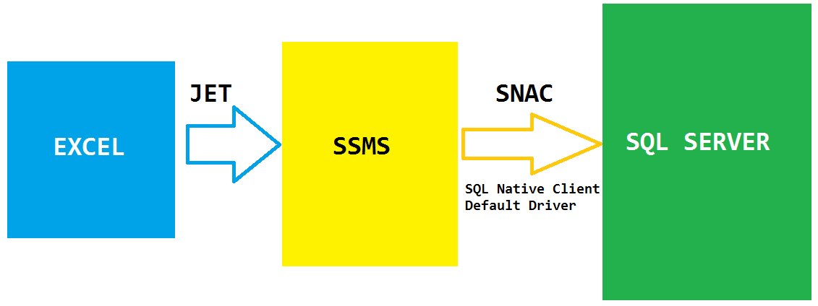

Launch SSMS > Connect to SQL Server > Expand Databases Folder.

Right Click the Database you created in the previous classes >

Tasks > Import > Source: Excel, Destination: SQL Server >

Select Required Sheets > Set Table Names > Run Immediately > Finish.